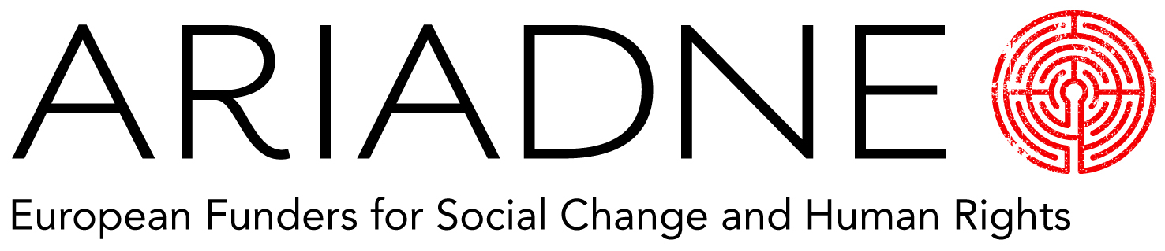

2016 Ariadne Forecast

Ariadne is creating its second Forecast for European Social Change and Human Rights Funders.

We are inviting you to help us create an overall forecast for what we think will happen in the year ahead, as a resource for the community as a whole. The questions we are looking answers for are:

What do you expect to be the most pressing challenge facing your grantees in 2016?

How do you expect your practice as a funder to change in the next twelve months?

What political event or sequence of events do you predict will have a substantial effect on your area of specialism?

What issue or field of practice do you think will become more important in 2016?

What issue or field of practice do you think will diminish in importance in 2016?

Your wildcard for next year:
Thank you for completing this.
Please return your questionnaires to lori.stanciu@ariadne-network.eu by December 7th 2015.

