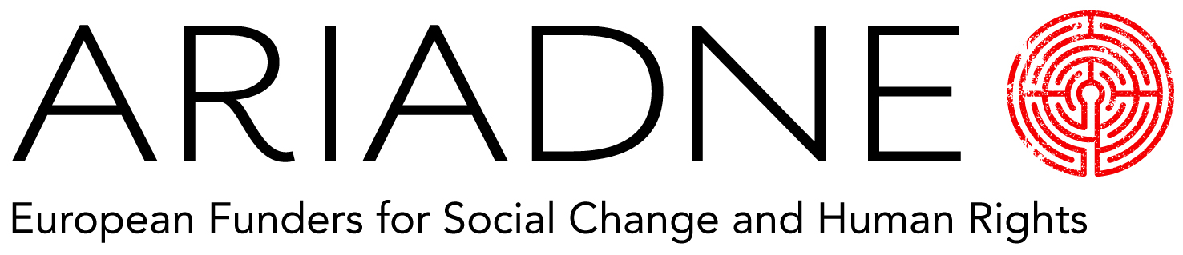

2017 Ariadne Forecast - Questionnaire

Ariadne is creating its third Forecast for European Social Change and Human Rights Funders. We’re inviting you to help us forecast what funders think might happen in the year ahead, to develop a resource for the whole community.

The questions we are looking for answers to are:

What do you expect to be the most pressing challenge facing your grantees in 2017?
How do you expect your practice as a funder to change in the next twelve months?
What political event or sequence of events do you predict will have a substantial effect on your area of specialism?
What issue or field of practice do you think will become more important in 2017?
What issue or field of practice do you think will diminish in importance in 2017?
Your wildcard for next year:

Thank you for taking the time to complete this questionnaire.
Please return it to hannah.stevens@ariadne-network.eu by December 7th 2016.

