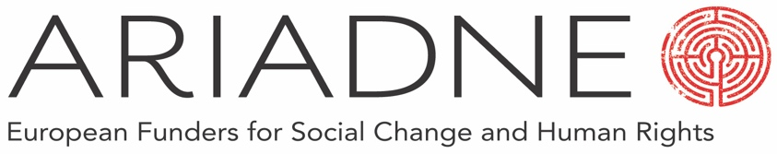

Ariadne Membership Contribution Form, 2022-2023

- Ariadne is a peer-to peer network that works to assist and extend the community of human rights and social change funders. You are free to use it in a way that best supports your work. We ask all member organisations for an annual contribution to help support Ariadne’s activities and to help us grow the community of funders. These contributions are enormously important to Ariadne and are its biggest single source of income.

- Only one individual from each organisation needs to complete this form and any contribution is counted as coming from the organisation represented. Any number of individuals within an organisation can join Ariadne, as long as they are involved with grant-making and donor activity and not fundraising.

- Below we suggest contribution levels based on the size of total annual donations/grant-making, but ultimately leave the level of contribution for each organisation to decide.

- Ariadne is a programme of Global Dialogue, a registered charity (1122052) and limited company (5775827) promoting human rights and social change through innovative and collaborative philanthropy. Contributions and grants will be paid to Global Dialogue restricted for use by Ariadne. 12% of all new income towards Ariadne will be used to cover the core costs of Global Dialogue, Ariadne’s fiscal host. If you have any further questions, please contact info@ariadne-network.eu.

Organisation:
Contact:
Address:
Country:
Email:
Phone:
Amount:

Please see suggested contribution levels, and bank details, overleaf.

For contributions in EUR:

Annual spending (EUR) | Suggested amount (EUR)
> €30,000,000 | €6,000 or more | Contributions can be made via bank transfer to Global Dialogue:
€10,000,000 - €30,000,000 | €5,000 or more | Account Name: Global Dialogue
€5,000,000 - €10,000,000 | €4,000 or more | Bank Address: HSBC, Lion House, 25 Islington High Street, London, N1 9LJ
€3,000,000 - €5,000,000 | €3,500 or more
€1,000,000 - €3,000,000 | €2,500 or more | Sort Code: 40-12-76
€300,000 - €1,000,000 | €1,000 or more | Account Number: 71170262
€20,000 - €300,000 | €750 or more | SWIFT Code: HBUKGB4B
Philanthropic Support Organisations | €500 or more | IBAN: GB44 HBUK 401276 71170262
Consultants | €75 – 125

For contributions in GBP:

Annual spending (GBP) | Suggested amount (GBP)
> £26,000,000 | £5,250 or more | Contributions can be made via bank transfer to Global Dialogue:
£8,700,000 - £26,000,000 | £4,350 or more | Account Name: Global Dialogue
£4,350,000 - £8,700,000 | £3,500 or more | Bank Address: HSBC, Lion House, 25 Islington High Street, London N1 9LJ
£2,600,000 - £4,350,000 | £3,050 or more
£870,000 - £2,600,000 | £2,200 or more | Sort Code: 40-03-33
£260,000 - £870,000 | £870 or more | Account Number: 91818260
£17,000 - £870,000 | £650 or more | SWIFT Code: HBUKGB4B
Philanthropic Support Organisations | £435 or more | IBAN: GB79 HBUK 400333 91818260
Consultants | £65 - 110

